

**DEPARTMENT OF ELECTRICAL AND ELECTRONICS ENGINEERING**

**BLUETOOTH CONTROLLED CAR USING ARDUINO UNO**

A MINI PROJECT REPORT

***Submitted by***

*VIKRAM.S (1NH18EE061)*

*JIBRAN ZAIDI HUSSAIN.C (1NH18EE022)*

*NIRUPAVARDAN REDDY (1NH18EE027)*

***In partial fulfillment for the award of the degree of***

*BACHELORS OF ENGINEERING*

*IN*

*ELECTRICAL AND ELECTRONICS ENGINEERING*



**DEPARTMENT OF ELECTRICAL AND ELECTRONICS ENGINEERING**

**BONAFIDE CERTIFICATE**

This Certificate that Mini project work entitled **“BLUETOOTH CONTROLLED CAR USING** **ARDUINO UNO”** Carried out by **VIKRAM.S–1NH18EE061**, **JIBRANZAIDI–1NH18EE022, APPAJI-1NH18EE004** are Bonafide students of New Horizon college of Engineering submitted the report in completion of project at Department of Electrical and Electronic Engineering during Academic Year 2019-20. It is Certified that all the Corrections/ Suggestions indicated for Internal Assessment have been incorporated in the report deposited in the department library. The project report has been approved as it satisfies the academic requirements in respects of Project work prescribed for said Degree.

Signature of GuideSignature of HOD

**(DR.RAMKUMAR**.**S)** **(DR.RAMKUMAR.S)**



**Acknowledgement**

With immense pleasure and deep sense of gratitude, I wish to express my sincere thanks to my supervisor **Dr.Ramkumar,** Head of the Department, Electrical and Electronics Engineering, New Horizon college of Engineering, without his motivation and continuous encouragement, this mini project would not be have been successfully completed.

It is indeed a great pleasure to recall the people who have helped us in carrying on this project Naming all the people who have helped us in achieving this project would be impossible, Yet I thank a selected few who have helped me in diverse ways.

We wish to excess our sincere gratitude to Dr.Manjunatha, Principal, NHCE, Bangalore for providing me with facilities to carry out this project.

We wish to express our sincere gratitude to our teacher and guide Dr Ram Kumar (HOD) NHCE for his valuable suggestions, guidance, care and attention shown during the planning, Conduction stage of this project work.

We express our sincere thanks to project coordinator, all the staff members and non-teaching staff of Department of Electrical and Electronic Engineering for the kind of cooperation extended by them.

**ABSTRACT**

The Aim of our project is to design a Mobile Remote control robot car. The Working is based on Android OS, Arduino microcontroller, motor drivers and Bluetooth module. Arduino is an open source prototyping platform. This is a very simple remote control car, with an Arduino and Bluetooth module. The idea is to first code the entire working using our previous knowledge of programming. The code will then be simulated on software and later be interface with hardware. Android is a very popular open-source operating systems based on the Linux kernel, used in mobile devices such as tablets and smartphones. Android has a very user-friendly interface which relies on direct interaction between users and the devices i.e., but using touch gestures. These gestures are like real world actions, which include swiping taping scrolling and pinching to control the onscreen objects, together with a virtual keyboard for taking input in text form. In the project, android smartphones has an installed application which is used for controlling the robot unit. the smartphone already comes with inbuilt technology to establish connections. The technology we have used is Bluetooth

The controlling remote can be any smart device with a android. All the controls of the vehicle will be on app on that device. We chose this for our major project as robotics has become a major part of our everyday lifestyle and also have a wide scope for the engineering field. It plays a vital role in the development of new technology

Pg.no 1

TABLE OF CONTENTS

|  |  |  |
| --- | --- | --- |
| SL NO | CONTENTS | PAGE NO. |
| 1. | ABSTRACT | 1 |
| 2. | ACKNOWLEDGEMENT | 2 |
| 3. | INTRODUCTION  LITERATURE SURVEY | 3 |
| 4. | CIRCUIT AND BLOCK DIAGRAM | 4 |
| 5. | LIST OF COMPONENTS  BLUETOOTH HC 05 MODULE  ROBOTIC TECHNOLOGY  BASED ARDUINO  RC MODULE  ARDUINO UNO  ANDROID SOFTWARE  ANDROID APPLICATION  USER INTERFACE | 5  6  7  8  9  10 |
| 6. | FUTURE SCOPE  &  REFERENCE | 11 |

Pg.no 2

**INTRODUCTION**

Smartphones has quite changed the traditional ways of human to machine interaction. Smartphones is now a vital part of person’s life. Android is a software platform for mobile devices that include a operating system. All of its essential tools are combined in software called SDK which stands for Software Development Kit. We know that all the manual operations of writing this paper is to develop an Android App for controlling the robot using Bluetooth. It is used for various advantages over others wireless technologies. Hardware technology utilizes in smart phones has also greatly improved. Hence we can say that Android Smartphones will serve a great benefit for industrial, commercial and other general purpose application.

**LITERATURE SURVEY**

Various researchers have been made by different researchers in developing this project. However, they serve a different application and have different technology implemented Some of those papers are mentioned below stating their technology and application.

Vito M Guardia (1) has evolved the method of Bluetooth technology by developing an android app for a robot which is driven by a microcontroller. The central idea of his work is to show that one android app can be operated using totally different electronic devices.

Jorge Kanavos (2) has developed android controlled robot automation main aim of his project was transfer of information wirelessly between a smartphone and a robot and developing the robot and its communication system underneath a low price and open source philosophy he used 3D design techniques to style the structure of the robot with facilities if parametrical modelling software. The style, when fed to 3D printer can print the parts to assemble the robot simply he used Arduino microcontroller and Wi-Fi technology in this robot

M Selvam (3) in his paper has projected design and develop a robotic system which has wireless camera attached to it for surveillance. Bluetooth was implemented in his project for providing connection between robot and smartphone. Wireless night vision camera used for providing remote surveillance. The video which is recorded by camera is then transmitted to TV unit through Radio Frequency signal. He used 8051 micro-controller for the robotic unit.

Pg.no 3

**RESEARCH GAP OF THE PROJECT**

Generally prior research shows that Arduino microcontroller application are very successful in robotics design, developing and implementation It is a very clear that Arduino made it easy to develop robotics applications easily, yielding people to focus on open source applications. This process also improved the platform of the Arduino.

Table 1 shows recent studies dealing with Arduino based robotic design and development I n the sense, It this sense it can be seen clearly that some studies mainly focused on microcontroller robotic applications using Arduino board ( Ghaghara, sandman & Soman, 2014; Kharvinen,2011).

On the other hand other studies only concentrate on designing and developing process of educational robotics systems by using Arduino(Balogh,2010; Baylor,& salgado,2011).

From a different perspective, as, Sadhu, Vyas, Konar, & Bhattacharya (2015) showed a real time cooperation between two robot while transporting a stick from starting position to fixed goal position. Some studies focus on controlling Arduino based robotics systems by Android base APPs, which require Bluetooth remote connections ( Kulkarni, Grama, Suresh , Antony, 2014; Patoliya, Mehta & Patel, 2015; Pahuja & Kumar, 2014).

Pg.no 4

**CIRCUIT AND BLOCK DIAGRAM**

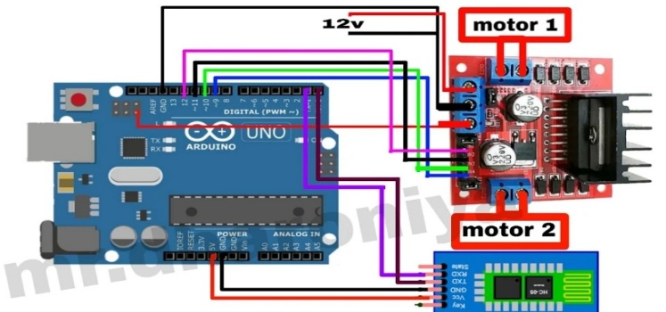

Fig 1.2

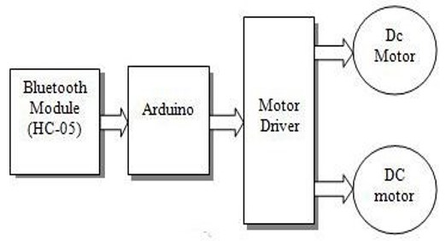

Fig 1.3

The Block Diagram of our system consists of a Bluetooth module, an Arduino kit and a couple of motors for driving the car.

This drivers are used to control the dc motors. The Arduino Uno, which is small android chip, resides at the centre of unit. It is responsible for communicating with android smartphones, using Bluetooth module and controls the motor using the motor drivers. RC unit is powered using 9V battery connected to this Arduino.

Pg.no 5

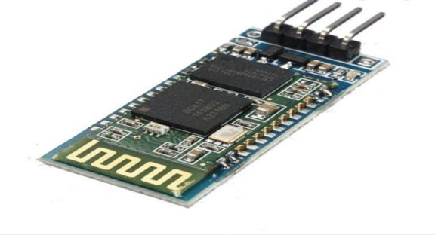 **HC-05 BLUETOOTH MODULE**

Fig 1.4

The HC-05 Bluetooth Module has 6 pins As follows: VCC,GND, TX, RX Key and LED. It comes pre programmed as a slave, so there is no need to connect the key pin unless you need it changed it to master mode the major difference between master and slave modes is that slave mode the Bluetooth module cannot initiate a connection. It can however accept incoming connections. After the connection is established the Bluetooth include transmission that transmits and receives data.

The default data transmission rate is 9600kbps.

The range for Bluetooth communication is usually 30m or less. Module has a factory set pin of “1212ewhich is used to pair the module to a phone.

Frequency 2.4Hz ISM band, power supply: + 3.3VD3.5mA, Working temperature 20 ‘+75 Centigrade

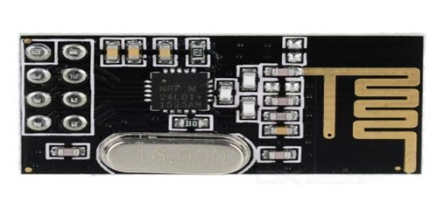**RC MODULE (NRF24L01)**

Fig 1.5

RC Module is the main working unit of this system. This unit consists of the Arduino chip, the two motor drivers and a connected to the circuit. Motor drivers are used to control the dc motors. The Arduino Uno, which is a small android smartphones using the Bluetooth module and controls the motor using the motor driver. RC unit is powered using 9V battery connected to this Arduino chip. The command for controlling the module is received using Bluetooth module HC-05

Pg.no 6

**ARDUINO UNO**

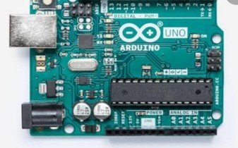 Fig 1.6

Arduino boards are small electronic circuits including AT-mega microcontroller and other electronic components. There are different types of Arduino boards that their functionality are having same, but their size, pin numbers and microcontrollers capabilities are different. The basic idea behind the Arduino comes from the facts it is open source and available to everyone interested in developing their new projects.

Arduino IDE(Integrated Development Environment) is also very easy to install, use, and develop new sketches based on the integrated. Arduino boards has different types of shield So it can be used for developing new projects easily.

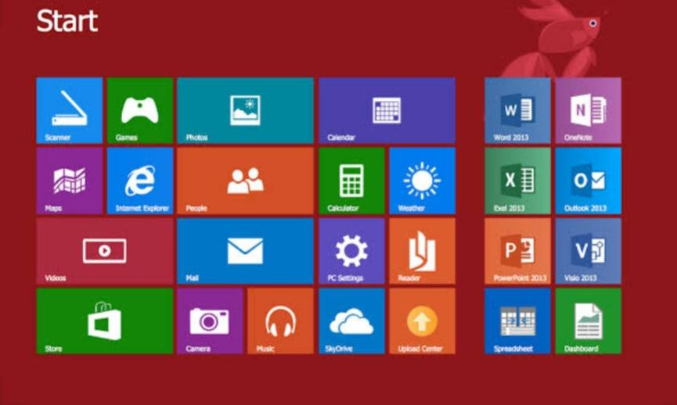**USER INTERFACE**

Fig 1.7

The user interface of overall system is provided using the custom made android app using graphical user Interface (GUI). The GUI provides user, the various controls modes, to Control dynamically the robot unit. When the app is started we first established the connection between app an RC unit using Bluetooth The GUI of android provides a user friendly real time experience to the user, to control the robot.

Pg.no 7

**ARDUINO BASED ROBOTIC TECHNOLOGY**

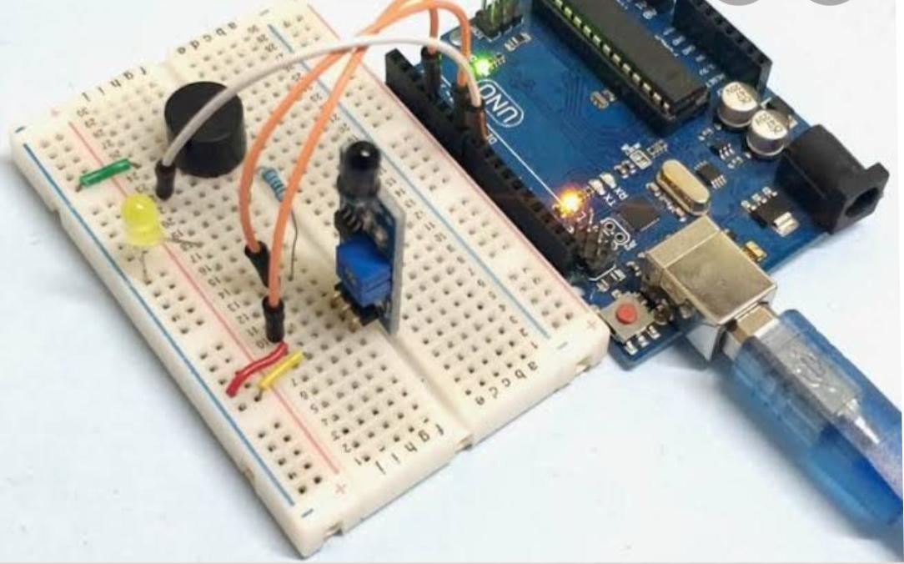

Fig 1.8

The answer to question of Why Arduino lies beneath Arduino flexible and user-friendly structure. It is very easy to distinguish Arduino boards from microcontroller due to its simple and accessible user experience. The Software and hardware is based on Arduino based technologies understandable for beginners, Yet flexible enough for advanced users For Example thinking of getting started with robotics applications. In this sense Hau-Shiue Juang & Lump(2013) in their study reported the design construction and controls a two wheel self balancing robot.

David Mellisin, Italy Arduino boards starting point was not education. In electronic, especially for robotics system the idea of DIY(Do it yourself ) developed rapidly with the introduction of Arduino. Later, researchers appreciated the freedom of Arduino Boards and looked for new opportunities for their projects to create new Ideas.

Banzai (2008), as a co- founder of Arduino, published a book titled as Getting Started with Arduino. In that he had explained “The Arduino philosophy is based on making design rather than talking about them. It is a constant search for faster and more powerful ways to build better prototype. We have explored many prototyping techniques and developed ways of thinking with our hand.”

Pg no.8

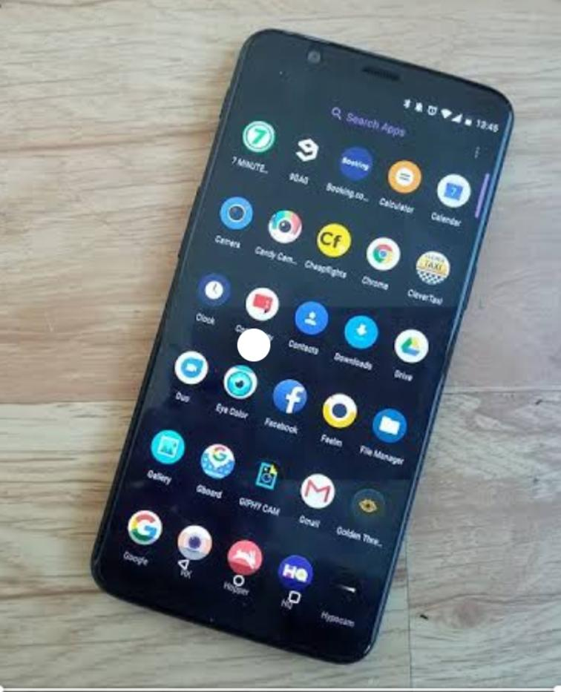**ANDROID SMARTPHONES**

Fig 1.9

Android is a very popular open-source operating systems based on the Linux kernel, used in mobile devices such as tablets and smartphones. Android has a very user-friendly interface which relies on direct interaction between users and the devices i.e., but using touch gestures. These gestures are like real world actions, which include swiping taping scrolling and pinching to control the onscreen objects, together with a virtual keyboard for taking input in text form. In the project, android smartphones has an installed application which is used for controlling the robot unit. the smartphone already comes with inbuilt technology to establish connections. The technology we have used is Bluetooth

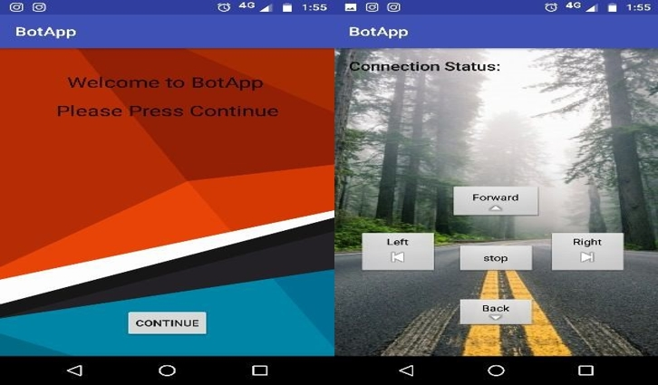 **ANDROID APPLICATION**

Fig 2.0

An application was developed in the software Android Studio. App can be installed on an android smartphone to control the RC unit. The app shows buttons for movement of the car in different directions. These commands are as follows: Forward, Backward and Right. The code for the application is written in C++.

Pg.no 9

**FUTURE SCOPE**

As per our requirements. If we use this for the surveillance purpose. We can implement the cameras or thermal sensors along with other sensors l. Once u develop the android app, the robot can respond to intuitive forum gestures based on the acceleration sensor. The data respond to your voice, click a button or swipe on touchscreen. Further if we want improve Accuracy of the rover, we can even implement sensors so controlling rover from remote place can be possible. We can Implement GPS system so it can be semi autonomous. The proposed work can be enhanced with the help of more security Function like passwords and so on.

**REFERENCES**

Internet Al-Fuqaha, A Guizana, M., Muhammad, Aledhari, M., & Ayyash (2015).

of things A survey on enabling technologies, protocols and application

IEEE Communications surveys & Tutorials, 17(4) 22347-2376

Albrecht, W., Bender, P., & suss man, K. (2012)

Integrating microcontrollers in undergraduate curriculum. Journal of Computing Science in Colleges,27(4), 45-52.

Alexander, A., Osun, A.R., & Oniga, S (2012). Personal assistant robot. 18th international Symposium for Design and Technology in Electronic Packaging (SIITME)

Al-Sahib, N. K. A., & Azeez, M. Z (2015). Build and Interface Internet Mobile Robot.

Pg.no 10